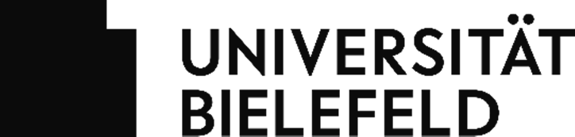

Regulations for University Operations at Bielefeld University during the Coronavirus Pandemic
Organizational Decree dated 31 March 2022, in force from 4 April 2022

The regulations stipulated in the Organizational Decree from 23 March 2020 (in the amended version from 20 March 2022) will be repealed as of 4 April 2022, with the exception of the rules governing trust-based working hours and Home Office (see Item 3).

On 4 April 2022, the regulations as specified in the workplace hygiene concept for staff members and the hygiene concept for teaching and studying in the attached appendices will go into force in the respective versions.

The provisions of Item 3 in the Organizational Decree will continue to apply until 24 April 2022, at which time they will then expire. For staff members who fall under the applicable scope of statutory FlexWork regulations, this also applies from 25 April 2022.

In all other matters, applicable legal requirements in the latest valid version must be observed.

Contact
Email: coronavirus@uni-bielefeld.de Bielefeld University
The Chancellor

Appendix 1: Workplace Hygiene Concept for Staff Members
Appendix 2: Hygiene Concept for Teaching and Studying

